Updated 10/18/2020

**GNS3 LAB-0: Install and set up**

PREREQUISITE:

You must have a VM ready computer and a way to run a VM in this lab I will be using VMware Workstation. (GNS3 offers VM options for VirtualBox, VMware Workstation and Fusion, VMware ESXi, and Microsoft Hyper-V)  
*GNS3 VM defaults are 2GB ram, 1 core

**PART 1: GNS3 VM**

Go to <https://www.gns3.com/software/download-vm> to get the correct VM for your VM software   
*This tutorial will be using the 2.2.15 VMware Workstation version  
*Important make sure that you VM and GNS3 are using the same version

Extract the VM from the ZIP and power it on to confirm it is working

**DELIVERABLE 1: Record of the startup screen for VM**

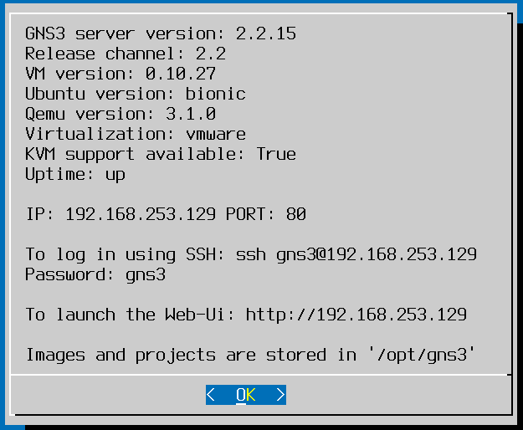

**PART 2: GNS3 DESKTOP**

Makes a GNS3 account at their website

Go to <https://www.gns3.com/software/download> and download the latest version of GNS3 for your OS   
*this tutorial will be using the 2.2.15 windows version

Run the installer keeping the default values  
Next > I agree > next > local install > next > next > next > no > start GNS3 > finish

After a moment you will get to the setup wizard

Select Run appliances in a virtual machine > next

Do not change from the default > Next

**DELIVERABLE 2: connection successful!**

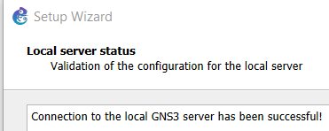

Select your software

Select the GNS3 VM you made from the dropdown in part one

Make sure you have the correct input for the hardware

Next > Finish

**DELIVERABLE 3: screenshot of Server summary showing green**

